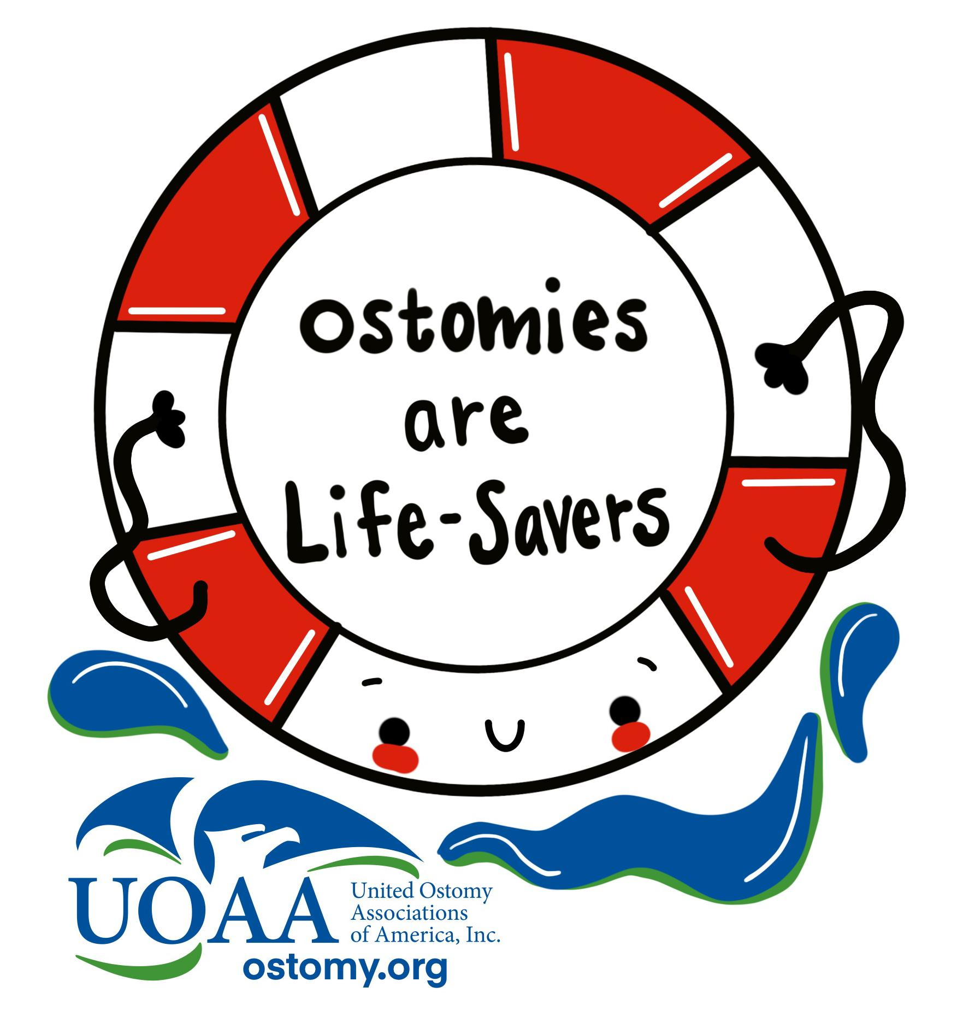
Sample proclamation:

Support from a Governor, Federal or State Legislator, Mayor or local governing body can increase awareness about Ostomy Awareness Day. Use the sample below to request public recognition of Ostomy Awareness Day through a proclamation – a government document that officially recognizes an observance in your community.

Ostomy Awareness Day
“Ostomies Are Life-Savers”

WHEREAS, an ostomy is a type of surgery that creates an opening (stoma) in the abdomen that allows for the removal of bodily waste when a person has lost the normal function of digestive or urinary systems due to birth defects, colorectal cancer, bladder cancer, Crohn’s disease, ulcerative colitis, and other medical conditions. They are also necessary in cases of severe abdominal or pelvic trauma resulting from accidents or from injuries sustained during military service. The bodily waste passes through the stoma into an ostomy ‘pouch’ on the outside of the body or in the case of continent diversion surgeries, an internal surgically created reservoir.
WHEREAS, approximately 725,000 to 1 million Americans have an ostomy, with approximately 100,000 new ostomy procedures performed each year and
WHEREAS, ostomy or continent diversion surgery can occur at any age and affects people from all ethnic backgrounds
WHEREAS, largely through the efforts of United Ostomy Associations of America, Inc., (UOAA) and its over 265 Affiliated Support Groups, Americans needing these surgeries are becoming more aware of the opportunities for education, mutual aid, advocacy and support that are of such great benefit to them and their families and
WHEREAS, the United States of America celebrates Ostomy Awareness Day with United Ostomy Associations of America annually on the first Saturday of October and
WHEREAS [community, area, or organization] is committed to increasing public understanding of “ostomy” to eventually help dispel the fear of those about to undergo this surgery, as well as the fear that confronts their families. This day can serve as a reminder to the American public that this is a life-saving and life-restoring surgery and
WHEREAS [community, area, or organization] recognizes the need that public education and awareness is vital to ensure those who are living with an ostomy face no discrimination and are accepted as normal, healthy individuals. Through education and awareness we can erase the myths, stigma and embarrassment that are sometimes associated with having an ostomy and
WHEREAS [community, area, or organization] and other government and private sectors are deeply committed to the proper care and advancement of knowledge about bowel and urinary diversion surgery as a result of birth defects, disease, injury and other digestive disorders and
WHEREAS, to increase public acceptance of ostomy surgery and continent diversion surgery and to help the country better understand that “Ostomies are life-savers”, [community, area, or organization] is designating “Ostomy Awareness Day” on October 7, 2023
NOW, THEREFORE, [I/we] , _______ of the [city/town/state], do hereby proclaim October 7, 2023 as “Ostomy Awareness Day - Ostomies Are Life-Savers”, and I call upon all residents of the [city/town/state] to unite on this day in a showing of support that people living with an ostomy are living proof that ostomies save lives.
IN TESTIMONY WHEREOF, I have hereunto set my hand and caused to be affixed the Great Seal of the _______ on this ________ day of ____________, 2023.

